- Advertisement and promotion

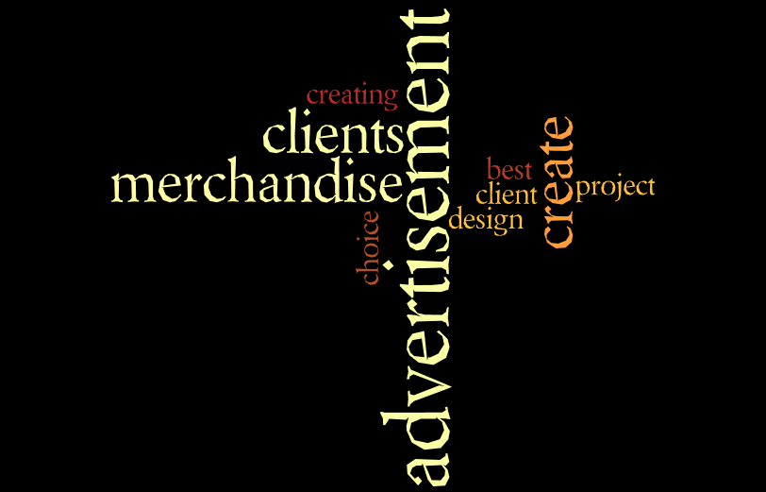
Doing business without advertising is like winking at a girl in the dark. You know what you are doing but nobody else does.

- Watch the film PR 2.0?
Match the remarks with the cartoons from the film (Put the numbers in de cells)
- Something that has never done before
- This product is great
- Businessman has a great idea to produce a product
- title
- on line relation building
- to tackle the mystery of social media
- the right vehicle
- the right message to the right audience

- Presentation
Watch the film again and open the PowerPoint slide show PR2.0. Rehearse with a partner how you can tell the PR story to him/her.
- Advertising vs Promotion
Advertising is a one-way communication whose purpose is to inform potential customers about products and services and how to obtain them. Promotion involves disseminating information about a product, product line, brand, or company. It is one of the four key aspects of the marketing mix. Advertising may be one form of promotion.
 | Advertising | Promotion
Time: | Long term | Short term
Price: | Expensive in most cases | Not very expensive in most cases.
Suitable for: | Medium to large companies | Small to large companies
Sales: | Assumption that it will lead to sales | Directly related to sales.
Example: | Giving an advertisement in the newspaper about the major products of a company | Giving free products, coupons etc.
About: | A type of marketing tool | A type of marketing tool
Definition: | Advertising is a one-way communication whose purpose is to inform potential customers about products and services and how to obtain them. | A Promotion usually involves an immediate incentive for a buyer (intermediate distributor or end consumer). It can also involve disseminating information about a product, product line, brand, or company.
Purpose: | Increase sales, brand building. | Increase sales.
Result: | Slowly | very Soon

Differences in Timeframe
Promotions are time specific and may be short term while Advertising may be generically long term. For example: ABS company may start a promotion of giving free drinks at a mall for a day during the festive season, while the same company may advertise much before about their drink at the start of the festive season and extend it during and beyond the season. Advertising is aimed towards the long term building of the brand while Promotion is aimed at the short term tactical goal of moving ahead in sales.

Types of promotion and advertising
Promotion is generally divided in two parts:
- Above the line promotion: Promotion in the media.
- Below the line promotion: All other promotion. Much of this is intended to be subtle enough that the consumer is unaware that promotion is taking place. E.g. sponsorship, product placement, endorsements, sales promotion, merchandising, direct mail, personal selling, public relations, trade shows.
Advertising can be of the following types:
- Media: Commercial advertising media can include wall paintings, billboards, street furniture components, printed flyers and rack cards, radio, cinema and television ads, web banners, mobile telephone screens, shopping carts, web popups, skywriting, bus stop benches etc.
- Covert Advertising: Covert advertising is when a product or brand is embedded in entertainment and media. For example: John Travolta wearing only "Diesel" clothing in a movie.
- Television Commercials: Virtual advertisements may be inserted into regular television programming through computer graphics. It is typically inserted into otherwise blank backdrops.
- Internet Advertising: This is the newest form of advertising wherein web space is used and email advertising is used.

Relationship of Sales with advertising and promotions
Typically promotions are directly linked with sales while advertising is an assumption that it may lead to sales. For example: Giving 20% discount on products may attract a customer and induce instant sale while giving a general brand creation advertisement in the newspaper may not induce immediate sale.

Cost of advertising vs promotion
Promotions are directly linked to sales and hence for small companies it may be easier to use promotional methods. Advertising may be more expensive for small companies and it may not be feasible for them while in advertising it is being assumed that adverts will lead to sales.
For example: A store may give 20% discount on its products which may increase sales while the same shop may find it difficult to advertise this in various medias.

obtain | verkrijgen
disseminating | verspreiden
assumption | onderstelling
incentive | aansporing
subtle | subtiel
endorsement | goedkeuring
merchandising | verhandelen
covert | verborgen
embedded | ingebed
inserted | geplaatst
induce | veroorzaken
hence | vandaar
feasible | uitvoerbaar

Answer the next questions.(Dutch)
  - In the table you see a comparison between advertising and promotion; what is similar?
  - Which is directly related to sales?
  - Which is more feasible for large companies?
  - Give an example of covert advertising?
  - Can you describe what above the line promotion is?
  - And what is virtual promotion?
  - Mention 5 sorts of media for commercial advertising.
  - Do you think promotion is at the tactical or strategic level?
  - Which form is mostly used for brand building?
  - Mention 3 everyday examples of promotion.

- Make an ad(vertisement)
- Check, recheck and check your ad copy again.
- If possible, and if you know how, use the golden ratio for your advertisement design.
- Ads cost a lot of money, and a good ad takes your dollar a long way. It might be worth paying a professional copywriter for a great ad.
- Less is always more. The less a reader has to read, the less a listener has to take in, bodes well for your ad.

Tips

Designing an Advertisement
- 1
Choose a memorable image. Simple but unexpected is often the best route to take. For example, these stark, colorful silhouette ads that barely even show the iPods they’re peddling couldn’t get much more straightforward, but because they don’t look like any other ads, they are instantly recognizable.
Distinguish yourself from your top competitor(s). A burger is a burger is a burger, but if you let yourself think like that, you’ll never make your sale. Use your ad to highlight your product’s advantages over that of your competitors. To avoid lawsuits, keep to statements about your product, not theirs. For example, this Burger King ad mocks the size of the Big Mac while speaking the literal truth: that is a Big Mac box, after all, leaving McDonalds no legal ground from which to retaliate.
3
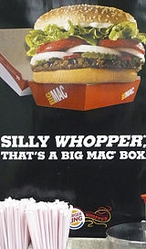
Design a business logo (optional). A picture says a thousand words, and if a logo is effective enough, it can render text unnecessary (the backwards Nike checkmark, the Apple bitten apple, the McDonalds arches, the Chevron shell). If you're running a print or television advertisement, try to develop a simple, appealing image that will stick in the minds of viewers. Consider these points: Do you already have a logo? If you can, think of fresh and creative ways of re-imagining it.
Do you have a commonly-used color scheme to work with? If your brand is instantly recognizable by the colors in the ad or the logo, use this to your advantage. McDonalds, Google, and Coca-Cola are good examples.

Find a software or technique creating your advertisement. How you create your ad will depend on which medium you're using to advertise. Here are some basic suggestions to get you started: If you're making a small-scale print ad (such as a flyer or magazine advertisement), try using a program such as Adobe InDesign or Photoshop. Or, if you're looking for a free option, you can use GIMP or Pixlr.
  - If you're making a video ad, try working with iMovie, Picasa, or Windows Media Player.
For an audio ad, you can work with Audacity or iTunes.
For a large-scale print ad (such as a banner or billboard), you'll probably have to contact a print shop to get the work done. Ask which software they recommend using.

